CDAC-Mumbai

Subject: Pattern Challenge in Java

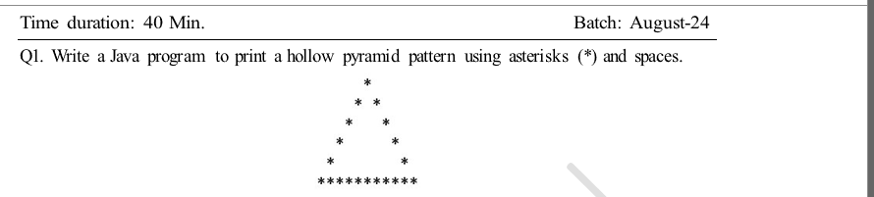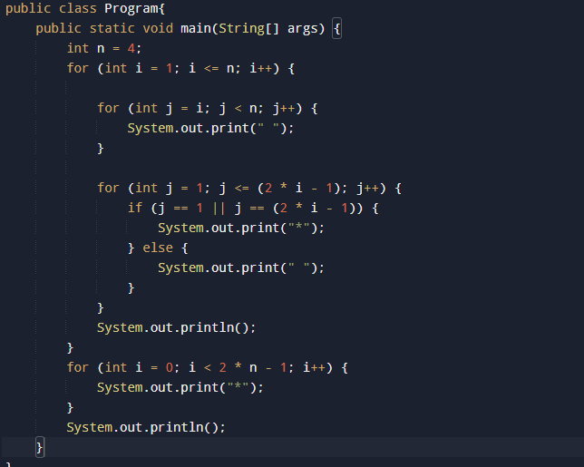

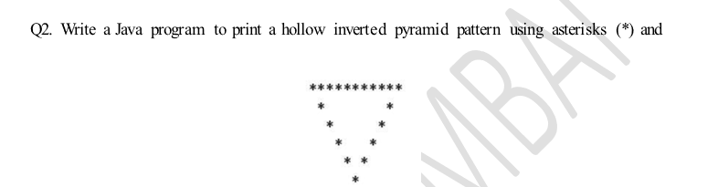

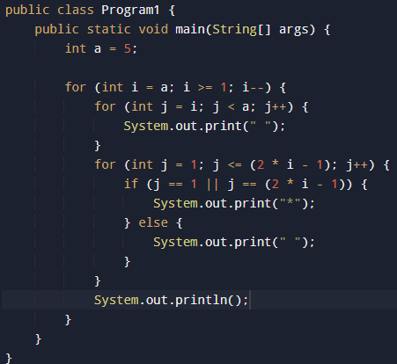

space.

Time duration: 40 Min.

Batch: August-24

Q1. Write a Java program to print a hollow pyramid pattern using asterisks (\*) and spaces.

Q2. Write a Java program to print a hollow inverted pyramid pattern using asterisks (\*) and

Q3. Write a Java program to print a pyramid pattern of alphabets, starting from 'A', using

A

BCD

EFGHI

JKLMNOP

QRSTUVWXYZ

Q4. Write a Java program to print a hollow right triangle pattern using numbers and spaces.

Q5. Write a Java program to print a Palindrome Number Pyramid.

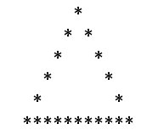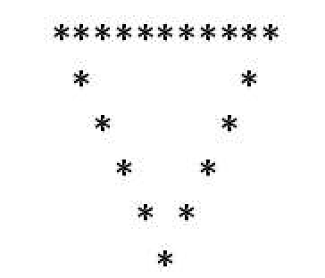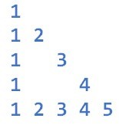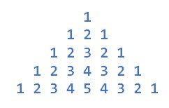

Q6. Write a Java program to print a diamond pattern using numbers.

1

121

12321

1234321

12321

121

1

Q7. Write a Java program to print the following pattern using numbers.

Q8. Write a Java program to print the following pattern using numbers.

Q9. Write a Java program to print the following pattern using numbers.

1

x 8 + 1 = 9

12

x 8 + 2 = 98

123

x 8 + 3 = 987

1234

x 8 + 4 = 9876

12345

x 8 + 5 = 98765

123456

x 8 + 6 = 987654

1234567

x 8 + 7 = 9876543

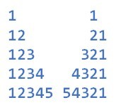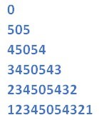

12345678 x 8 + 8 = 98765432

123456789 x 8 + 9 = 987654321

Q10. Write a Java program to print the following pattern using numbers.

